CSE 311

Assignment 1

Name: Shamim Ali Mullick ID: 1731123642

Section: 10

Lecture 1

Activity 1

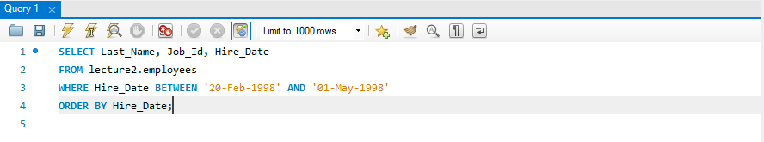

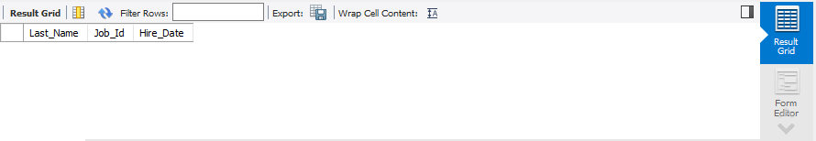

Activity 2

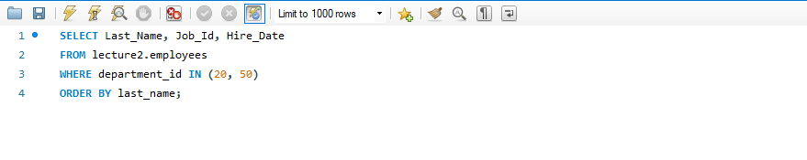

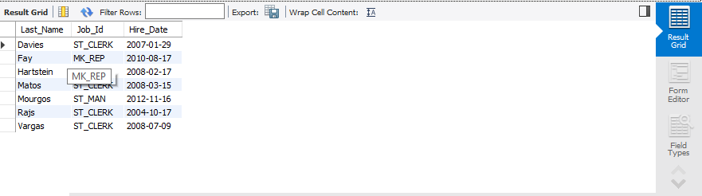

Lecture 2

Activity 1

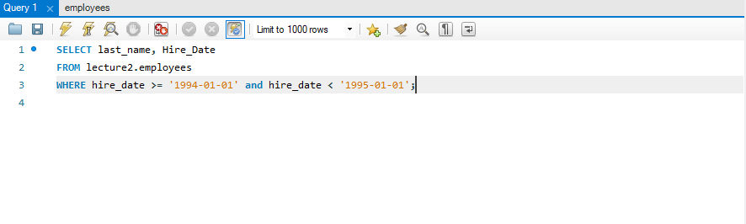

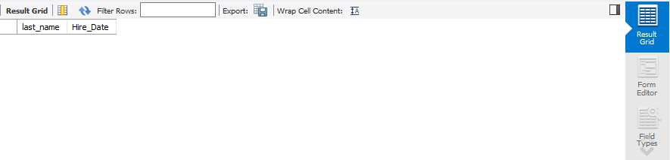

Activity 2

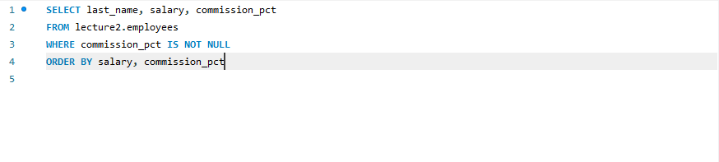

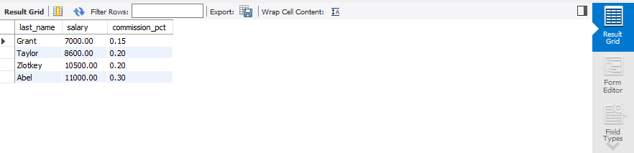

Activity 3

